Generator How to Guide
Generator Control Panel
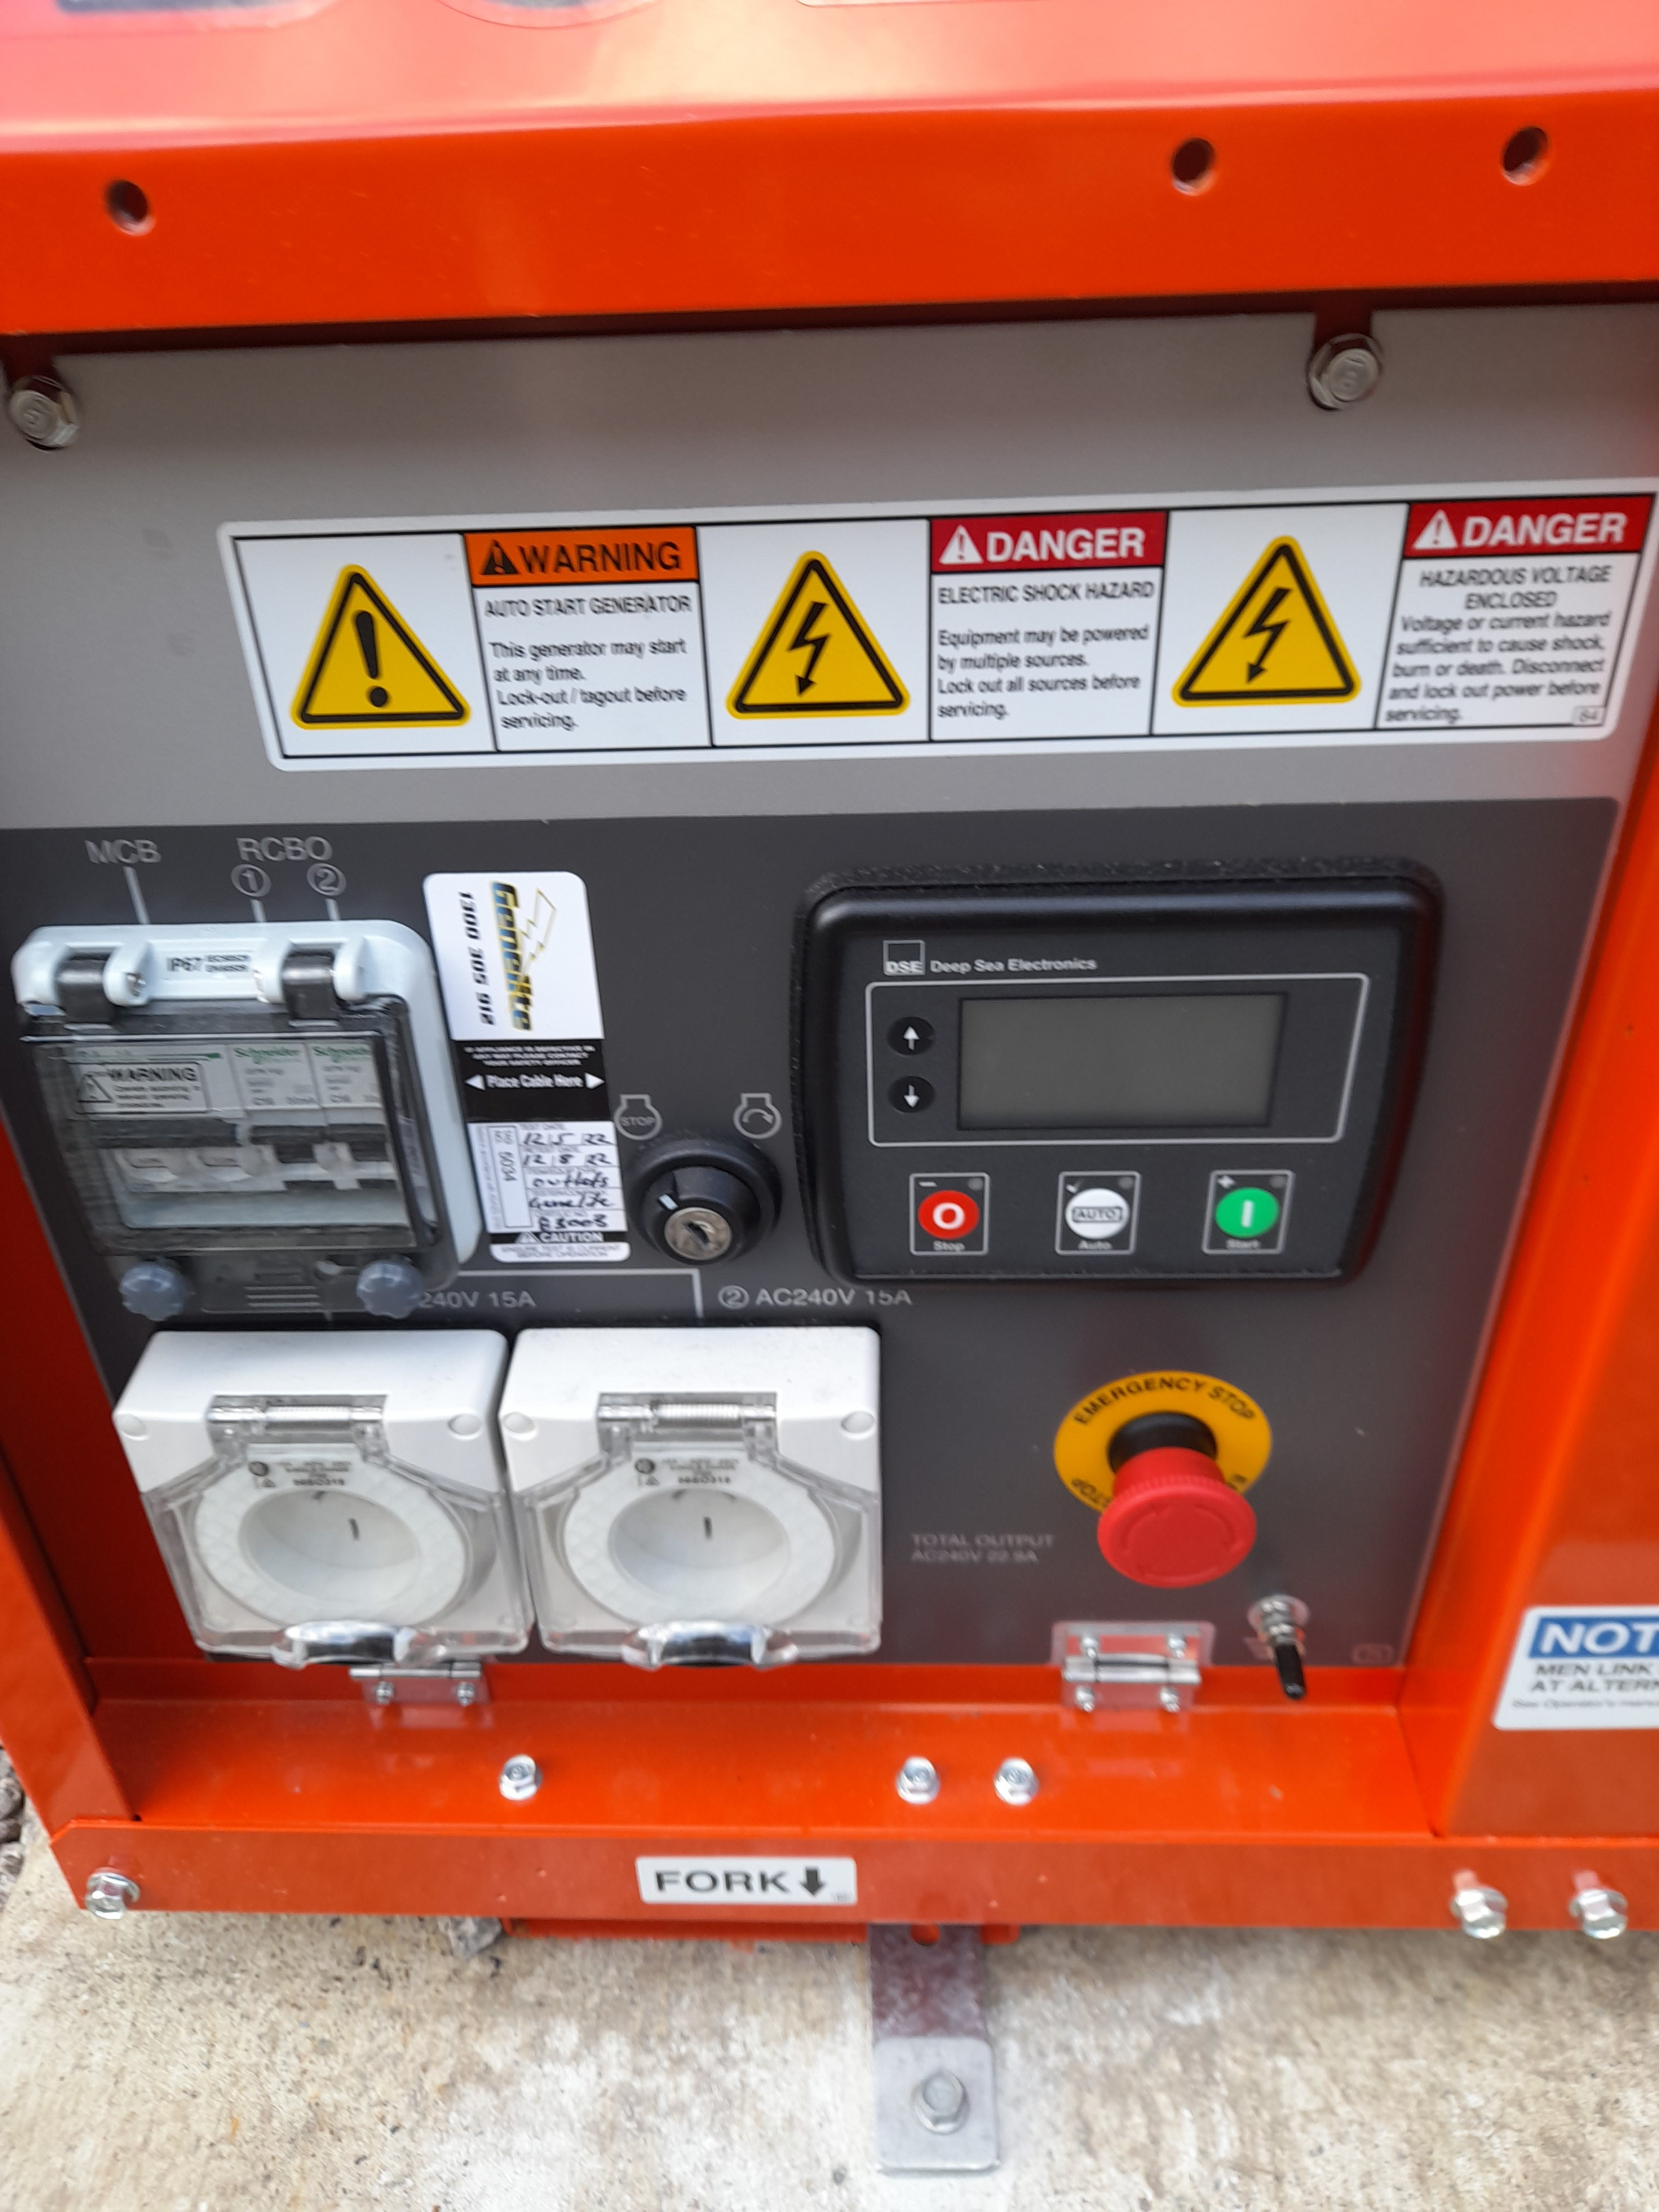
Key Switch
Key Off
Key On
Power Stop
Auto start
Power start
Emergency Stop

Instructions for Use

- Insert Key into the key switch and turn to the on position.
- Press the Auto start button, you should see a green light
- When you lose power, the generator should automatically start.
- To Test if the generator is working, Turn the power off in the mains board on the side of the house Wait 60 seconds and the generator will start.
- The generator will turn off automatically when the power turns back on.
- If the generator hasn’t stopped after 60 seconds you can press the Power stop button.
- If the generator is not working, please refer to the trouble shooting guide attached.
- Ensure ONLY diesel is used in the generator.

